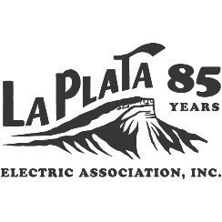 | P.O. Box 2750, Durango, CO 81302-2750 Phone: (970) 247-5786 ● Fax (970) 247-2674  www.lpea.coop
R E S O L U T I O N 2025 - 17
Capital Credit Retirement
WHEREAS, the Board of Directors of La Plata Electric Association, Inc. has decided to retire capital credits to its members and former members, and
WHEREAS, the Board of Directors has decided to retire a total of $1,000,000.00 of capital credits to members and former members, and
WHEREAS, the Board of Directors has determined the retirement of capital credits will not impair the financial position of the Cooperative and is not in conflict with existing mortgages and
WHEREAS, the retirement will be distributed on a "first in, first out" (FIFO) basis for $1,000,000.00 of Co-operative Patronage Capital for the year 2003.
NOW THEREFORE BE IT RESOLVED by the Board of Directors of La Plata Electric Association, Inc. that the $1,000,000 capital credit retirement be approved.
I, John Witchel, Secretary of La Plata Electric Association, Inc., do hereby certify that the above is a true and correct copy of a resolution adopted by the Board of Directors of La Plata Electric Association, Inc., at a regular meeting held in Durango, Colorado, on October 15, 2025, at which meeting a quorum of directors was present and voting.

John Witchel, Secretary

Dated at Durango, Colorado this 15th day of October 2025.


